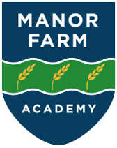

**Art Policy**

2024-25

**Intent**

At Manor Farm Academy, we believe that education in Art provides an essential foundation for creative development and an awareness of Cultural Capital. We will therefore provide a broad range of learning experiences in which the pupils are able build skills systematically through our Art Framework, which reflects this. We will provide an environment in which pupils are able to develop and explore specific Art skills, artists and knowledge. They will regularly explore and experiment with materials throughout their time at Manor Farm Academy.

We strive to ensure that:

* Pupils feel secure, valued and confident to be challenged.
* Pupils find learning to be a pleasurable and rewarding experience whilst taking risks or trying something new.
* Pupils are interested, motivated and positive.
* Pupils develop curiosity in the world around them and further afield.
* Pupils are encouraged to persevere and to develop independence and resilience.
* Pupils show self-motivation towards their own learning.

We will deliver a curriculum that:

* Will be taught in a way that is at least as ambitious as the National Curriculum expectations.
* Will have drawing at the center of all learning.
* Promotes and develops children’s diverse abilities and skills, understanding that outcomes will vary according to the pupil and that Art is a very personal response.
* Provides a stimulating and positive learning environment where children’s Art work is celebrated.

Our pupils will learn best because they will experience Art through the processes of:

1. Drawing

2 . Painting

3. Printmaking

4. Collage

5. Textiles

6. Sculpture

* They are provided with first-hand learning experiences and appropriate adult intervention.
* They are encouraged to use exploration and Art talk as vehicles for learning.
* The work of “real” artists is used as a stimulus for pupil’s own pieces.
* Pupils progress is tracked, assessed and recorded, then used to inform future learning opportunities.

The process of drawing will lead into each Art area of learning and provide a starting point for all other aspects of Art. Drawing will then lead naturally into other Art skills development. (See Appendix 1 and 2.)

**Implementation**

The subject Leader for Art will lead and monitor, evaluate, review and celebrate good practice. ***Art will be taught once a week for 1 hour for alternate termlets in both KS1 and 2.***

Each unit of learning in Art will have:

* Drawing as its initial response, usually recorded in sketch books.
* Lessons which closely follow the flow diagrams of progress attached to this document.
* Opportunities for pupils to explore materials and their properties. This includes mark making, surfaces used to mark make on, and in the case of sculpture, construction.
* Opportunities for pupils to draw upon past learning/ skills and knowledge of the work of real artists.
* Medium Term plans which help teachers to put together clearly focused lessons based on L.T. specifically chosen to ensure progressive learning.
* Subject knowledge that encourages pupils to be curious, ask questions and respond appropriately.
* Opportunities for pupils to respond in their own way within the perimeters of the L.T.
* Art vocabulary, as specified in the Art MTP, modelled clearly by teachers.
* Opportunities for pupils to learn about real artists and to use them as inspiration for their own work.
* Opportunities for pupils to revisit, change and adapt their ideas over time.
* A clear progression of skills, including the ‘Language of Art’ used within lessons by both staff and pupils.

In addition:

* The Art Subject Leader will seek appropriate and relevant training and the opportunity to keep developing their own subject knowledge, skills and understanding, so they can support curriculum development and their colleagues throughout the school.
* All staff will have direct access to the relevant training documents which have been recently delivered via the online school systems.
* Art will be celebrated within school through display, social media and newsletters.
* All appropriate Art resources will be stored centrally to ensure that all staff have access to the materials that they need.

**Impact**

At Manor Farm Academy, our pupils:

* Know what Art is and thoroughly enjoy the journey that Art takes them on. This includes experiential Art, Art from a range of diverse cultures and time periods.
* Understand that Art plays a vital role in them understanding the World around them, whether that be from studying the Art of today, or Art from the past.
* Enjoy the very individual way that they are able to respond within a L.T.
* Know that Art is personal. One person’s work can be very different to another's.
* Feel confident about trying out new ideas and concepts. They know that they can learn from what they do.
* Enjoy showcasing their skills and knowledge in Art.
* Increasingly use the Language of Art with confidence.

In addition, we measure the impact of our curriculum through the following methods:

* Monitoring of sketch books and work on display.
* Marking and verbal feedback.
* Learning walks.
* **Pupil discussion.**
* **Sketch book looks.**

**Lesson Planning & Delivery**

* Art planning and lesson delivery follow the flow diagrams of progress which can be found in Appendix 1 and Appendix 2 at the rear of this document.
* The L.T. which pupils learn within are carefully structured to allow individuality and progression of skills to intertwine.
* Sketch books are used from Year 1 onwards as a way to collect ideas, try out materials and techniques and to revisit as a working document throughout the pupil's time at Manor Farm Academy. An outline of how sketchbooks are used at MFA can be found in Appendix 3 at the rear of this document.

**Challenge** is not always needed to be printed in the form of a sticker or additional task (at the end of a lesson). Challenge in Art may come through

1.choice of material or medium,

2.scale,

3.audience

4.time

5.perspective.

The use of Key Questions (Manor Farm Question Matrix) and feedback both verbal and written all play a vital role in challenging pupils.

*Appendix 1.*

**Art Lesson Sequencing for Painting**

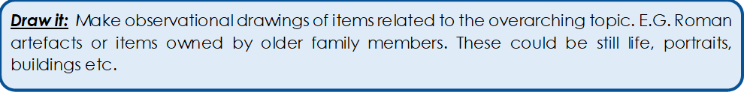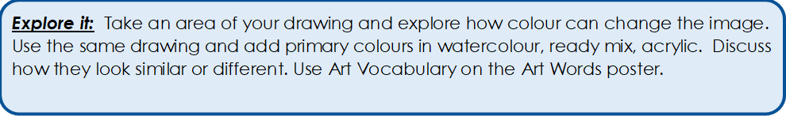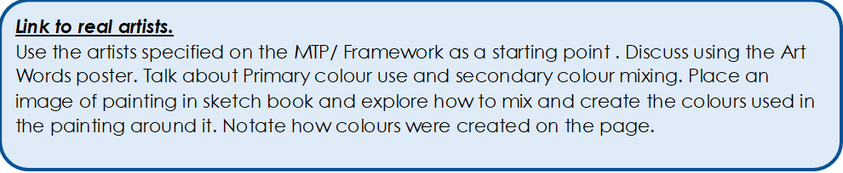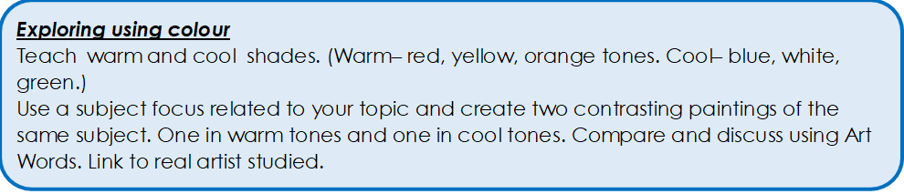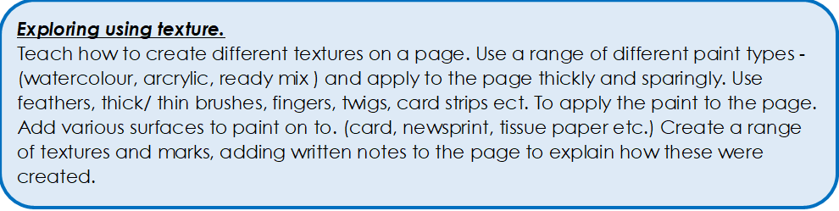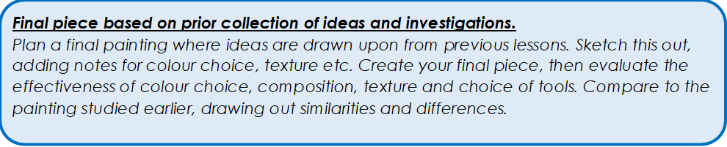

**Art Lesson Sequencing for Drawing**

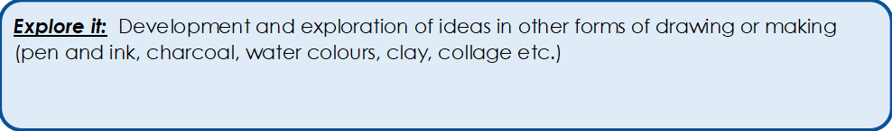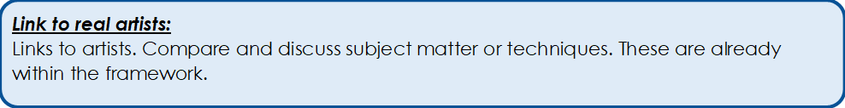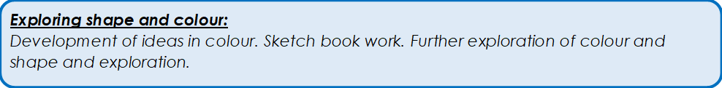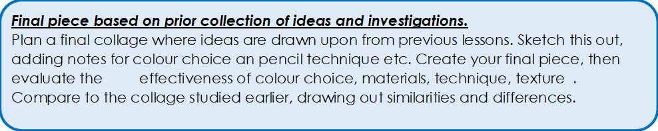

**Art Lesson Sequencing for Print Making**

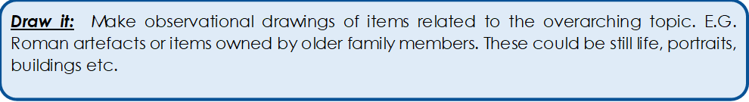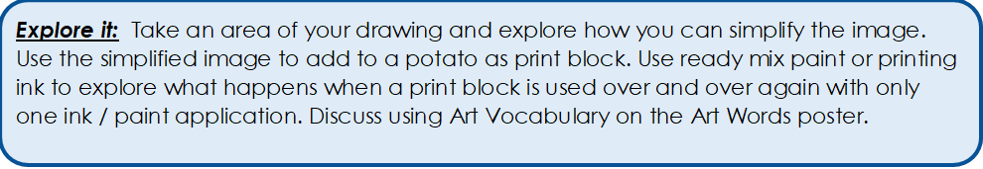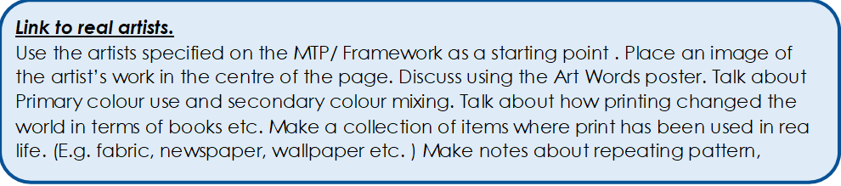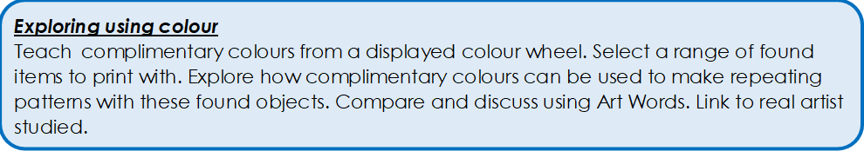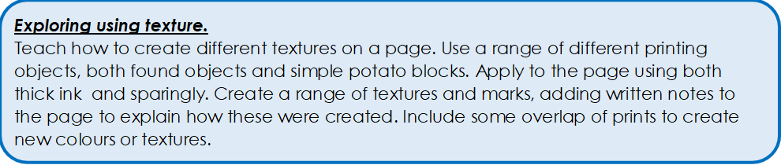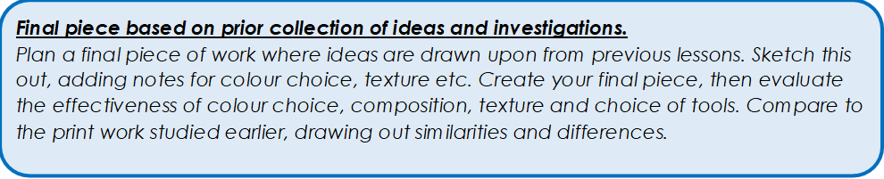

**Art Lesson Sequencing for Collage**

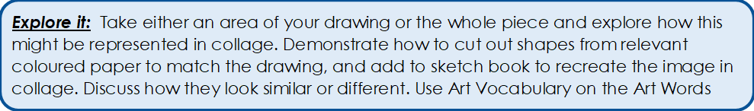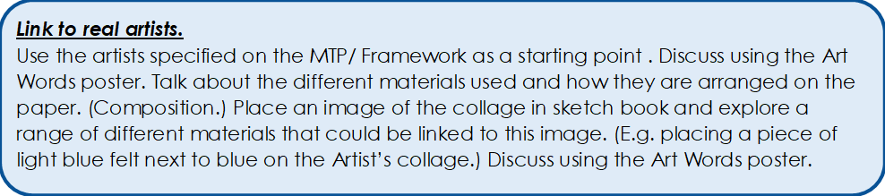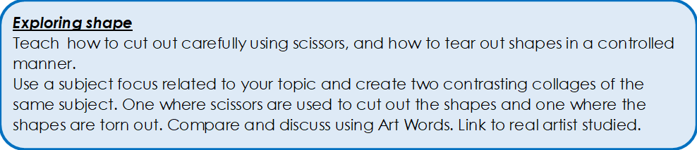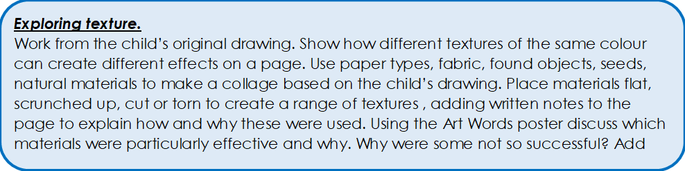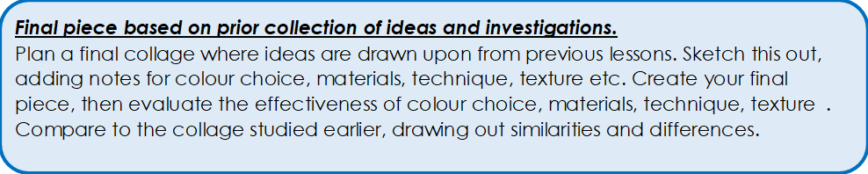

**Art Lesson Sequencing for Sculpture**

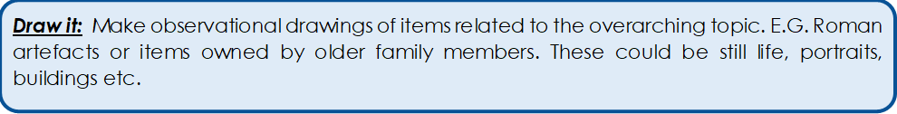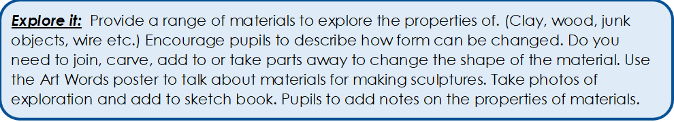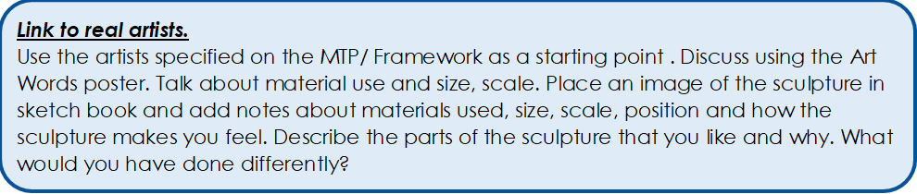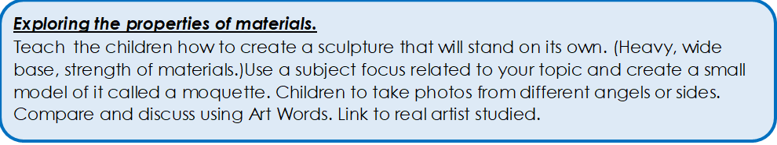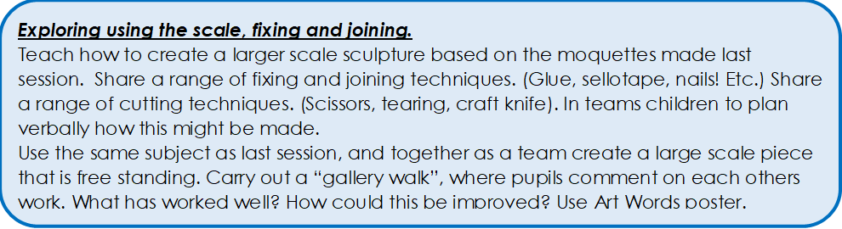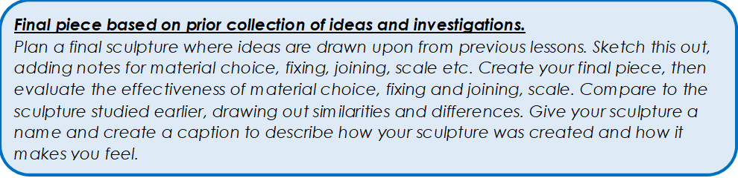

|  |  |
| --- | --- |
|  |  |
|  |  |

Appendix 2.



            
            
            
          
        
          
        
        