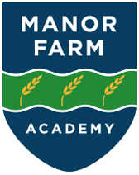

**D&T Policy**

2024-25

**Intent**

At Manor Farm Academy, we believe that our pupils should be equipped with the problem solving skills needed to participate successfully in an increasingly technological world. Our Design and Technology curriculum has been designed to ensure the progressive development of knowledge and skills and to foster the growth of the pupils own creativity so they design, make and evaluate innovative products. We strive to inspire, excite and engage the pupils in a problem-solving approach to Design and Technology where the pupils can be creative, evaluative and resilient, a skill which will prepare them for life after school.

We will deliver a curriculum that:

* Celebrates the achievements made through Design and Technology lessons and those achieved outside of school.
* Encourages pupils to apply their previous learning when presented with a problem-based task.
* Develops creative, technical and imaginative thinking in children.
* Enables children to talk about how things work and to develop their technical knowledge.
* Fosters enjoyment, satisfaction and purpose in designing and making things for a purpose.
* Builds on previous knowledge and skills so pupils will know more, remember more and understand more.
* Encourage children to select appropriate tools and techniques when making a product, whilst following safe procedures.
* In KS2, broadens children’s knowledge of the use of design and technology in the past, daily life and it’s impact within the rapidly changing world.
* Ensures children develop the cookery skills they’ll need for life after school.

**Implementation**

The subject Leader for DT will lead and monitor, evaluate, review and celebrate good practice. ***Art will be taught once a week for 1 hour for alternate termlets in both KS1 and 2.***

DT at Manor Farm Academy is planned and sequenced in a curriculum designed specifically for our children. The Long Term overview for DT throughout the whole school is as follows:

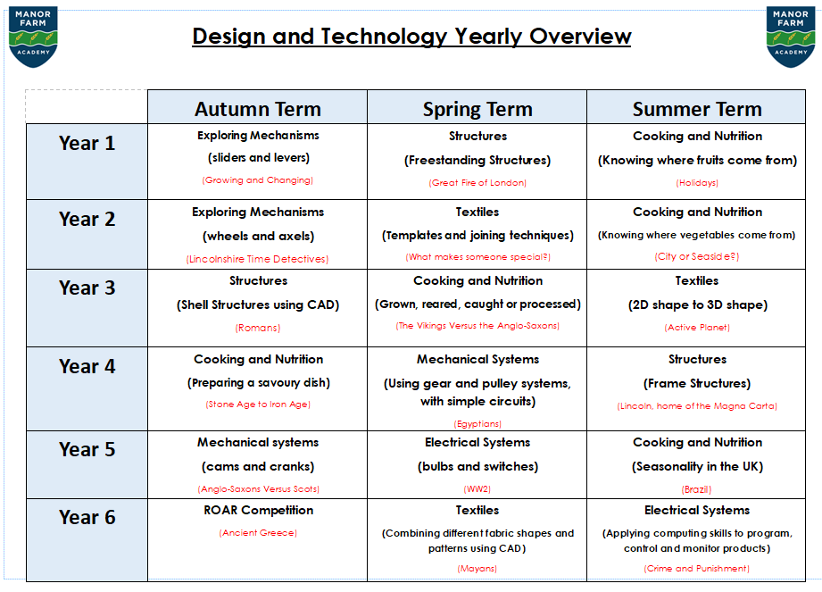

Each unit of learning in DT will have:

* A real life context to start the unit of learning, which gives the children a problem to solve.
* Each unit of learning will follow the following process, however more than one of the following areas may be covered within one lesson:

-Background Research

-Design Criteria

-Explore skills

-Design

-Make

-Evaluate

* DT lessons should typically contain some of the following elements:

Discussion: what they already know from experience, what they have learnt so far, what they will be finding out next. Where necessary, mind mapping and question boards are appropriate methods for recording these discussions if desired.

Teaching: directly to the whole class or through group or individual work.

Practical tasks: working within groups or individually, choosing suitable materials and tools, experimenting with materials, being encouraged to think creatively. Where groups are required, the teacher should consider which type of grouping will best suit the needs of the children.

Recording: diagrams, flow charts, model making, written explanations, designing: sketching, exploded diagrams, evaluating in a range of different ways.

Communicating: sharing ideas, knowledge, and what they have found out with each other, the teacher, other classes and adults as appropriate.

* Year group specific scaffolded sheets are used to ensure consistency and progression of skills.

In addition:

* The DT Subject Leader will seek appropriate and relevant training and the opportunity to keep developing their own subject knowledge, skills and understanding, so they can support curriculum development and their colleagues throughout the school.
* All staff will have direct access to the relevant training documents which have been recently delivered via the online school systems.
* DT will be celebrated within school through display, social media and newsletters.
* All appropriate DT resources will be stored centrally to ensure that all staff have access to the materials that they need.

**Impact**

At Manor Farm Academy, our pupils:

* Know what DT is and thoroughly enjoy the journey that DT takes them on. This includes

In addition, we measure the impact of our curriculum through the following methods:

* Monitoring of DT files and work on display.
* Marking and verbal feedback.
* Learning walks.
* Pupil discussion.