

Maths Policy

2024-25

Intent

At Manor Farm Academy, we inspire all children to achieve their full academic potential: we have high expectations and provide children with the opportunities to be successful. We strive to ensure children become confident and fluent mathematicians, who can articulate their understanding using specific mathematical vocabulary and problem solve and reason within a variety of contexts. In order to achieve this, we teach high quality, well-sequenced lessons that continually revisit and build on prior knowledge, which in turn prepares children for their next phase of education.

We will deliver a curriculum that:
- Promotes enthusiasm and enjoyment for learning through exciting and interactive teaching and learning opportunities;
- Equips children to solve problems by applying prior knowledge;
- Develops logical thinking, reasoning and problem-solving skills through challenge, questioning, natural curiosity and investigative approaches;
- Develops confidence in children so that they can articulate and communicate understanding both written and verbally;
- Provides a rich environment that promotes independence;
- Encourages a range of strategies to solve problems;
- Links mathematical skills to everyday life;
- Maintains high expectations for all learners within mathematics.

Implementation

The Subject Leader for Maths will lead and monitor, evaluate, review and celebrate good practice.
- The Maths curriculum will follow the White Rose Maths programme of study, adopting a mastery approach;
- Maths lessons will provide opportunities for children to explore concrete, pictorial and abstract approaches and will further develop children’s reasoning and problem solving skills;
- Maths will further support children to develop rapid recall of timetables.

Each unit of learning in Maths will have:
- A pre-assessment which assesses the children’s understanding of the objectives being taught in subsequent lessons;
- A cycle of lessons for each unit, which carefully plans for progression and depth, tailored to children’s needs, based on findings from the pre-assessment;
- Daily opportunities to recap and revisit previously taught concepts;
- Opportunities to explore a range of problem solving and reasoning style challenges;
- Appropriate scaffolding to support learning;
- Challenges that deepen understanding.

In addition:
- The Maths Subject Leader will seek appropriate and relevant training and the opportunity to keep developing their own subject knowledge, skills and understanding, so they can support curriculum development and their colleagues throughout the school.

Impact

At Manor Farm Academy, our pupils:
- Know what Maths is and why it is important to them and their future;
- Know how to apply Maths to ‘real-life- contexts;
- Enjoy Maths and show inquisitiveness and curiosity through questioning and exploration;
- Feel challenged and supported to reach their full potential.

In addition, we measure the impact of our curriculum through the following methods:
- NTS assessments + EOY2/6 past paper assessments;
- Pre-assessments;
- Early Years Framework;
- Y4 MTC;
- Marking & Feedback (in line with Marking Policy);
- Book Looks;
- Learning walks;
- Pupil Discussions;
- Pupil Progress Meetings;
- Data and Question Level Analysis.

Lesson Planning & Delivery
Maths planning and lesson delivery follows the White Rose Maths scheme (National Curriculum and ‘Ready to Progress’ mapping). Class teachers have the autonomy to adapt and amend planning and resources to suit the needs of their children, with them main aim of ensuring that learning is ambitious for all.
We show success in mathematics through:
Lesson Planning & Delivery:
- Maths is taught five times per week – this consists of a pre-assessment and subsequent lessons linked to the objectives on the pre-assessment
- Pre-assessment and learning targets are taken directly from the ‘steps’ in the White Rose Maths scheme of work to ensure adequate pitch and progression for all
- All pre-assessments inform future planning and necessary amendments are made to meet the needs of children to ensure learning is personalised e.g. where a child shows they are secure in an area of the pre-assessment, they will access more challenging work (Appendix 1)
Books (Appendix 2):
- Presentation is to a high standard and displays children’s pride in their learning
- Learning journeys mirror the scheme of work ‘steps’
- Worksheets are only be stuck in when needed to enhance and/or support the learning taking place e.g. providing an additional scaffold, displaying a worded problem etc
- Where possible, children are encouraged to record work in their books

Effective Feedback:
- Pre-assessments and subsequent lessons are marked in line with the Feedback Policy
- Live feedback and marking is used to move learning forward, to either address misconceptions or through scaffolded support or challenge
- Self and peer marking will be evident through the use of purple pens
  - Where children have made errors in their work, there will be evidence of how children have corrected/re-calculated a problem
  - Children do not just replace an incorrect answer with a correct answer, without addressing misconceptions (Appendix 2)

Scaffold & Challenge (Appendix 3):
Ideas for scaffold:
- Pre-teaching and/or Point of Need Intervention
- Modelling (silent/verbal/written in books)
- Working walls
- Highly scaffolded/worked examples (generic layers of support) that can be reduced
- Learning prompts/step by step guides
- Workshops/Guided Groups (evidenced with GW)

Ideas for challenge:
- Reasoning and problem solving questions provided by WRM
- Create, Investigate, Describe or Evaluate style questions
  - Step by step guides
  - Open-ended investigations
  - Creation of own problems
  - Evaluating effective methods
  - Considering multiple ways of solving/representing (CPA)
- Adaptation of questions – ‘what if…?’
- Written/verbal questioning

Challenges do not always needed to be printed in the form of a sticker/additional task (at the end of a lesson). This could be displayed on a working wall for children to record and respond to in their books.

Appendix 1
LPA journey.pdf
MPA journey.pdf
HPA journey.pdf

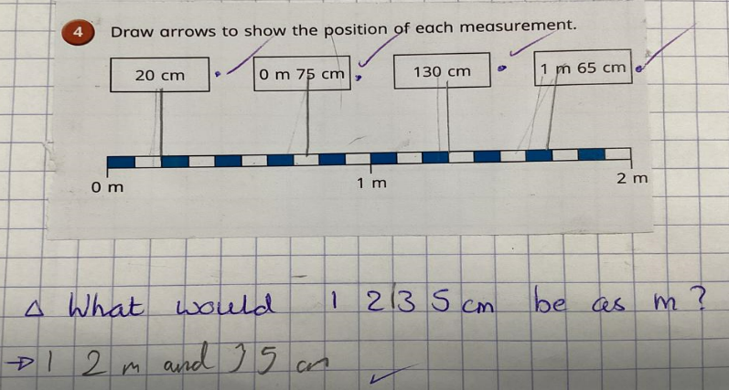
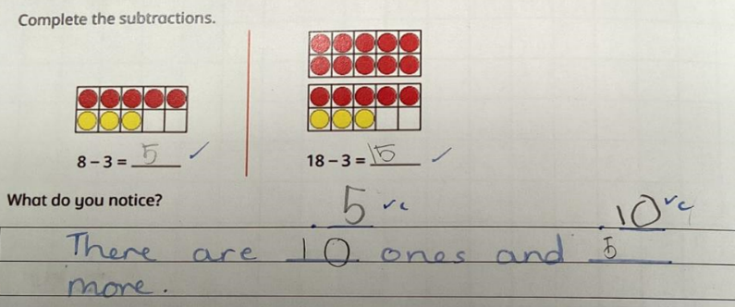
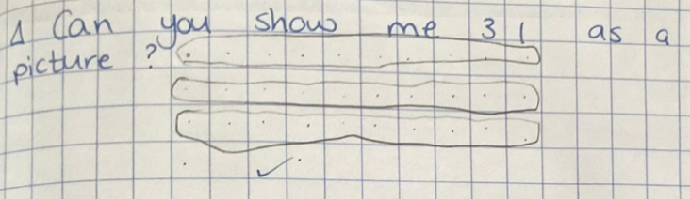
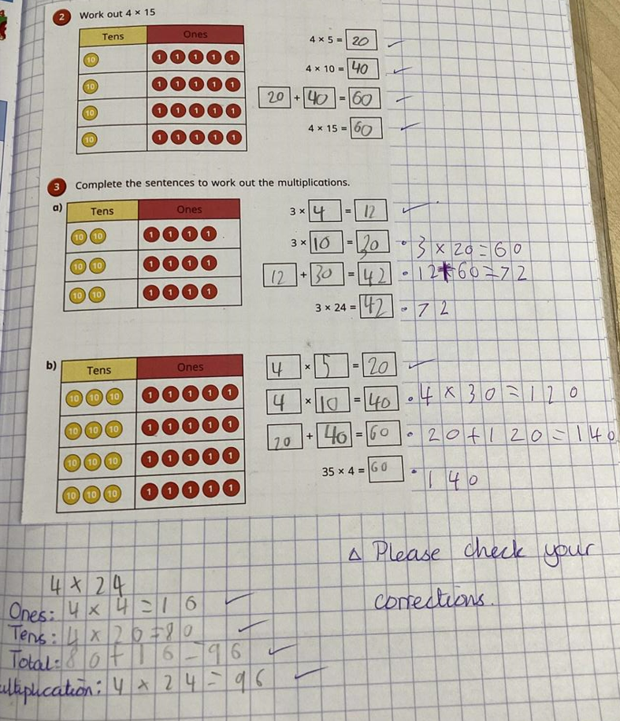
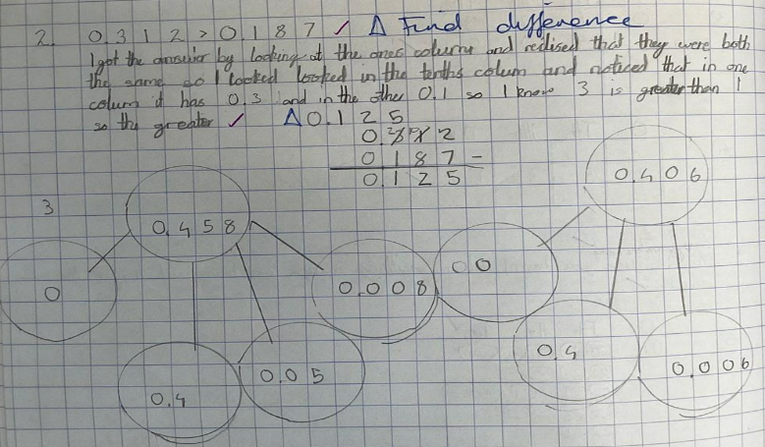
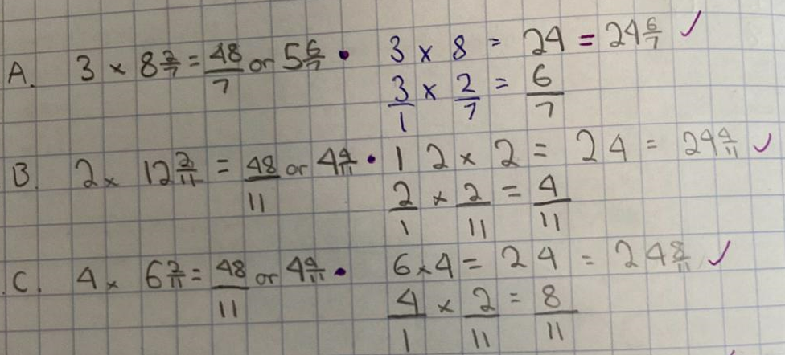
Appendix 2
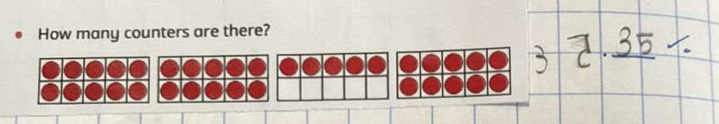
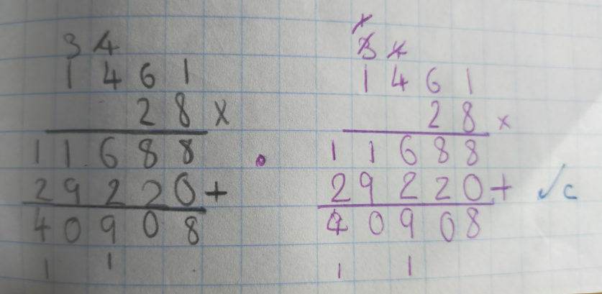

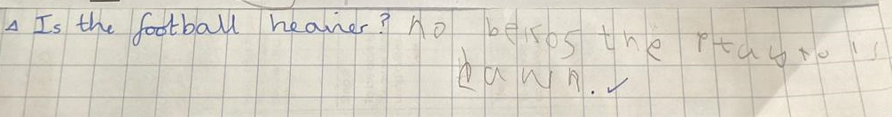
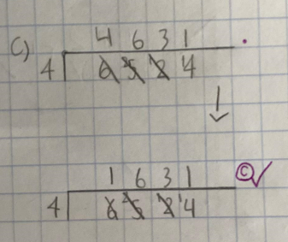
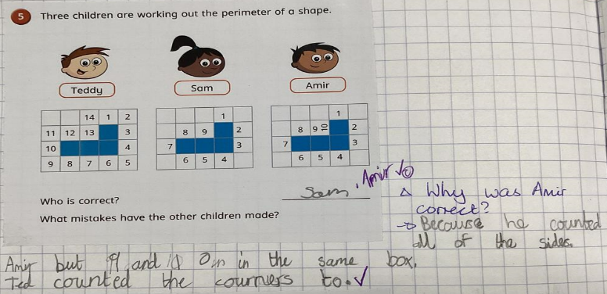
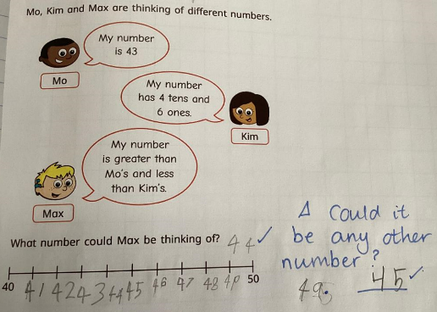

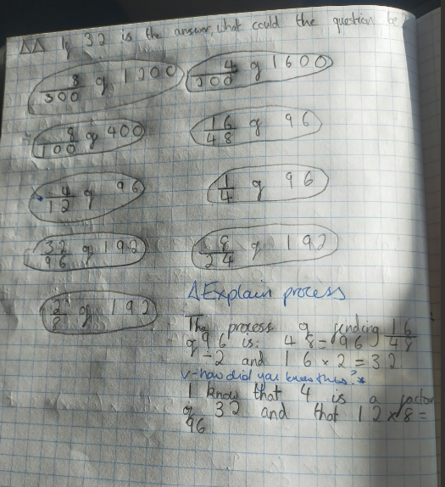
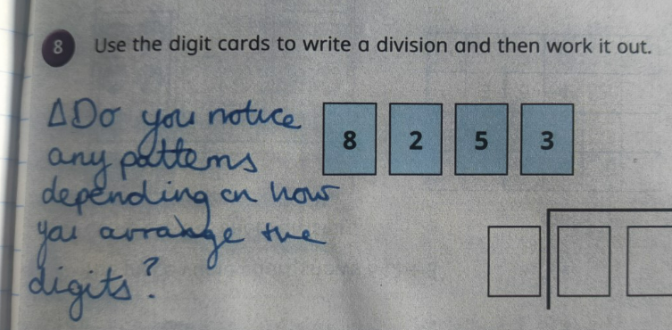
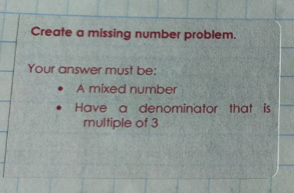
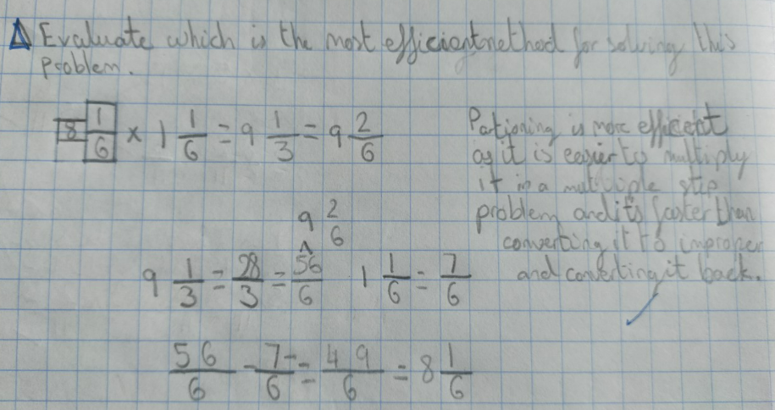
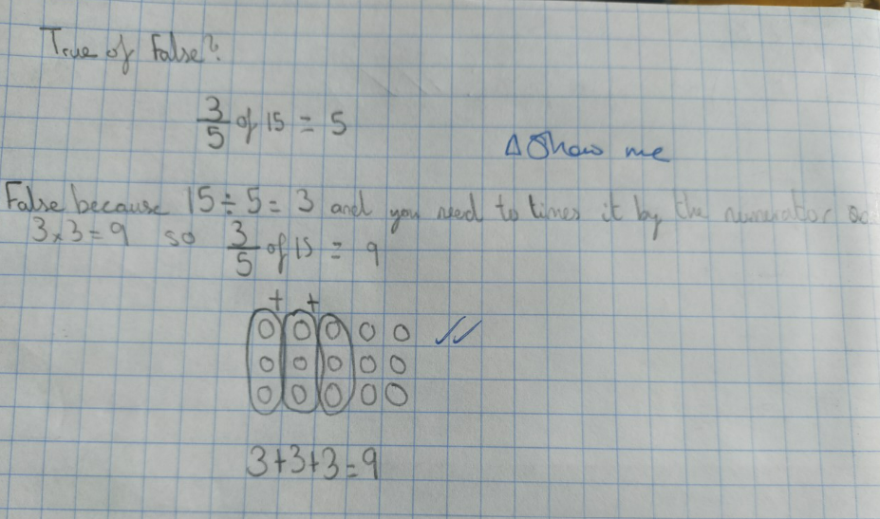
Appendix 3

