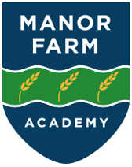

**Music Policy**

2024-25

**Intent**

At Manor Farm Academy, we believe every pupil should have the opportunity to develop a passion for music. Our music curriculum is designed to provide students with the repeated practice needed to achieve proficiency while systematically building on the interrelated dimensions of music, leading to deeper understanding and mastery of musical skills. We aim to foster an appreciation for music across various genres, time periods, and cultures, and integrate music with other subject areas.

Our curriculum will:

* Foster a love of music and develop students' talents through a wide range of curriculum opportunities.
* Celebrate music from diverse cultures, eras, and genres, encouraging respect for different musical preferences.
* Promote the use of musical instruments and hands-on learning experiences.

**Implementation**

The Subject Leader for Music will lead, monitor, evaluate, review, and celebrate good practices within the music program.

The Music curriculum will follow the Charanga Model Music Curriculum Scheme.

Music lessons will focus on practical learning, providing children with access to a variety of musical instruments.

Assemblies will offer opportunities to listen to music from diverse cultures, time periods, and genres.

Each unit of learning in Music will include:

* A listen-and-respond section
* Appraising pieces of music
* Improvising with instruments
* Playing instruments
* Singing
* Performing

Additionally:

The Music Subject Leader will pursue relevant training and continuously develop their own subject knowledge, skills, and understanding. This will enable them to support curriculum development and assist colleagues throughout the school.

**Impact**

At Manor Farm Academy, our pupils:

* Learn how to respond to pieces of music.
* Know how to identify musical instruments by their sounds.
* Learn how to sing.
* Learn how to play the glockenspiel.
* Learn how to play percussion instruments.
* Learn how to improvise with musical instruments.
* Understand how music makes them feel.
* Learn how to compose a piece of music.
* Learn how to perform.

Additionally, we measure the impact of our curriculum through the following methods:

Teacher assessments conducted during each lesson and recorded in the music log.

**Scaffold & Challenge:**

* Ideas for scaffolding:
* Modelling techniques and performances.
* Playing instruments alongside pupils.
* Providing step-by-step instructions.
* Guiding students in composing instrumental pieces.
* Using planning tools for composition.
* Adding extra notes on the glockenspiels using the scheme.

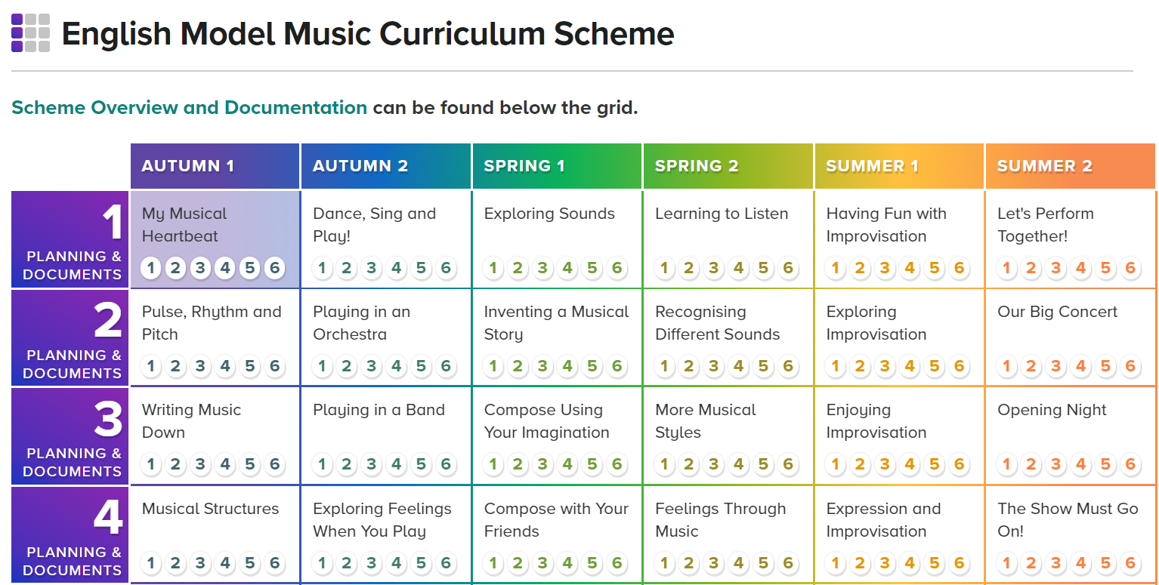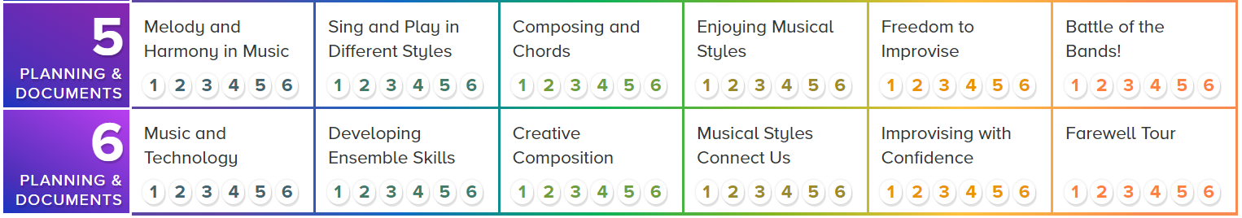

## **Scheme Overview**

## **What Is It?**

Charanga’s English Model Music Curriculum Scheme is aligned with the National Curriculum for Music and the non-statutory Model Music Curriculum (MMC) Guidance published by the DfE in 2021.

This Scheme provides clearly-sequenced units and lessons with week-by-week support for each year group. There are lesson plans, assessment documentation, a clear learning progression, as well as engaging and exciting songs and resources to support every lesson. Key Learning and Outcomes with ‘I Can’ statements are provided to be used alongside assessment grids.

Our Scheme follows a spiral approach to musical learning, with children revisiting, building and extending their knowledge and skills incrementally. In this manner, their learning is consolidated and augmented, increasing musical confidence and enabling them to go further. Teachers can adapt their teaching to respond to the strengths and needs of the children they teach.

**Our Approach to Education**

Our philosophy of music education is based on the principle that it should be fun and engaging for all concerned, and that every child is a born musician. Music plays a role in every aspect of our lives, wherever and whoever we are. For this reason, we divide the academic year into six units, each corresponding with one of our six recurring Social Questions, combined with a unique Musical Spotlight.

For more detailed support and information, please see the [Model Music Curriculum Scheme Guide](https://staging2.charanga.com/resource_library/products/pdfs/MMC_REVISED/curriculum_level_documents/overview/Key%20Documents/Model%20Music%20Curriculum%20Scheme%20Guide.pdf).

**Scheme Structure**

Our MMC Scheme is suitable for children aged 5–11, with six self-sufficient units per year. Each unit is structured into six steps which can be covered as you see fit, though a pace of one step per weekly lesson may suit the pace of your academic year well. The first step of each unit introduces that unit’s focus in terms of content, skills and knowledge; the middle steps then develop this, and the final, sixth step assesses the learning through exciting performances and activities.

**Songs at the Heart of Each Lesson**

At the centre of each step – each lesson – is a song around which the musical learning is centred. Each lesson has an easy-to-follow structure complemented by an array of supporting documents, lesson plans and resources that take you through listening, singing, performing, composing and improvising exercises with the children in your class.

To begin accessing the lessons and resources, click on the relevant year, unit and step in the navigable grid provided on-screen.