

**PSHE Policy**

2024-25

**Intent**

At Manor Farm Academy, we believe that the teaching of Personal Development is crucial to the pupils understanding of how their bodies and minds change and grow. They will learn about how to make and maintain healthy relationships. We promote the understanding of British Values throughout the whole curriculum. We teach the basic life skills and how to manage different social situations. Our Personal Development curriculum has been carefully planned and is bespoke to Manor Farm Academy with the intent to equip pupils with the lifelong skills they need to be a part of ever changing society. We strive to ensure that pupils feel able to ask for help, to understand who is within their support network and how to manage different social situations. Our aim is for every pupil to understand how to keep themselves and others safe and to understand how to prepare themselves for puberty. The pupils will be equipped with the knowledge of basic first aid, how to live more independently and how to manage their own mental health and support others.

We will deliver a curriculum that:

* Teaches pupils about the protective characteristics
* Is current and reflects the changing world
* Celebrates diversity
* Embraces the British Values
* Encourages independence and the development of life skills
* Promotes an understanding and openness surrounding puberty and growth
* Builds upon social skills to enable them to manage different social situation
* Ensures that mental health is essential to pupil’s development and equips them with the lifelong skills to manage their own well-being

**Implementation**

The Subject Leader for PSHE will lead and monitor, evaluate, review and celebrate good practice.

* The PSHE curriculum comprises of seven main areas. Social education, Philosophy and SMSC, Drug education, Well-Being, British Values, Life Simulation, Relationships and Sex education.
* The board and balanced curriculum is carefully planned to develop knowledge and skills in all areas of PSHE.
* The PSHE curriculum is bespoke to Manor Farm Academy and is reflective of the strengths and areas for development of the pupils.

Each term in PSHE, the pupils will have:

* 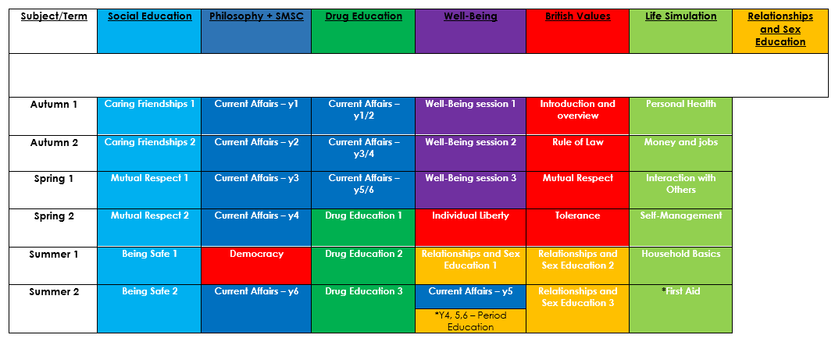1 lesson per week with a focus on 1 area of the PSHE curriculum.
* * sessions to be taught by Accredited and trained PSHE coordinator

In addition:

* The PSHE Subject Leader will seek appropriate and relevant training and the opportunity to keep developing their own subject knowledge, skills and understanding, so they can support curriculum development and their colleagues throughout the school.

**Impact**

At Manor Farm Academy, our pupils:

* Know how to manage different relationships
* Know how to show respect to all
* Know how to be safe in different situations
* Know about and are able to debate and discuss current affairs
* Know about drugs and the affects they can have on the body
* Know how to help themselves and others to have healthy minds
* Know about how their body’s change through puberty
* Know about periods and how to support themselves and others
* Know about sex education and how to be healthy

In addition, we measure the impact of our curriculum through the following methods:

* Session walk arounds to monitor teaching and pupils learning
* Pupil discussions to gather pupil voice and subject knowledge
* PSHE log’s to look at session evidence and assessment

**Lesson Planning & Delivery**

**Lesson Planning & Delivery:**

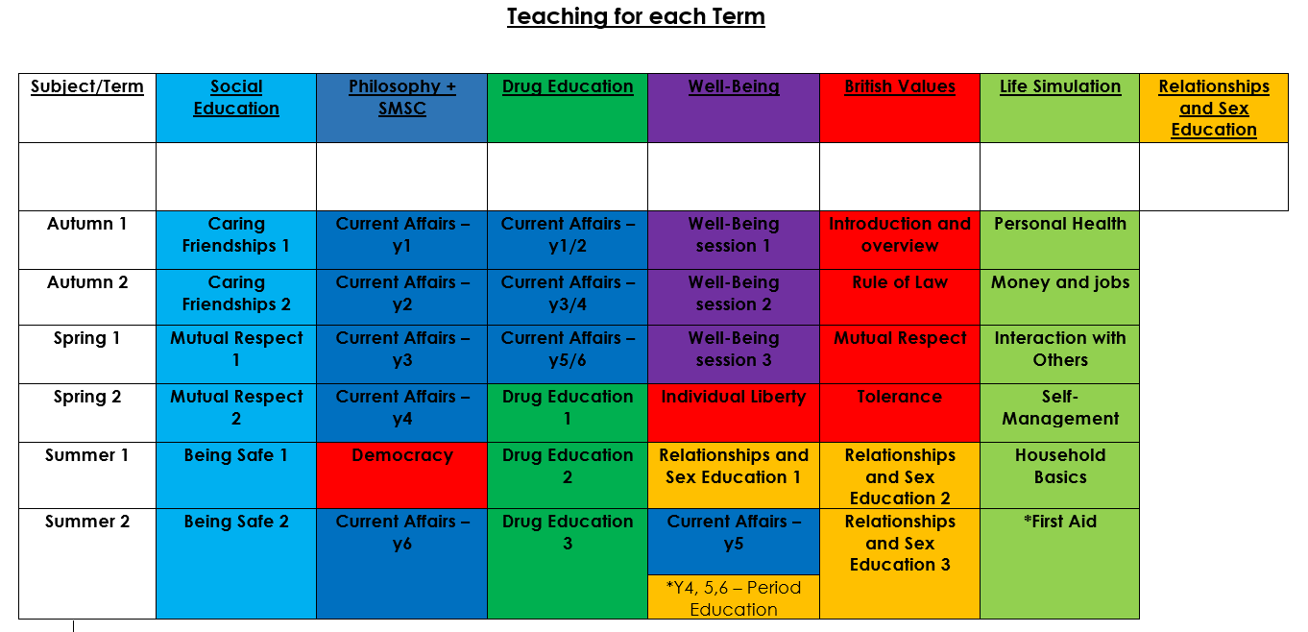

**British Values Overview**

|  |  |  |  |  |  |
| --- | --- | --- | --- | --- | --- |
| **Introduction** | **Rule of Law** | **Mutual Respect** | **Tolerance** | **Individual Liberty** | **Democracy** |

**Drug Education Overview**

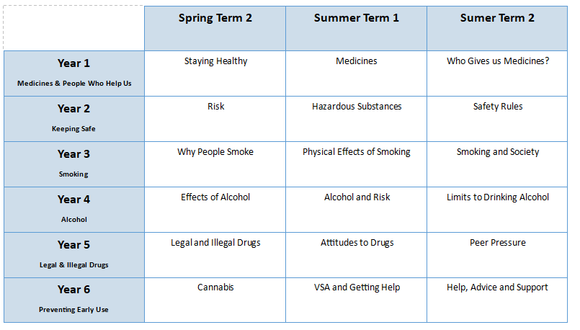

**Life Simulation Overview**

|  |  |  |  |  |  |
| --- | --- | --- | --- | --- | --- |
| **Personal Health** | **First Aid** | **Interaction with Others** | **Manipulation of Clothing** | **Self-Management and Survival** | **Household Basics** |

**SMSC and Philosophy Overview**

|  |  |  |
| --- | --- | --- |
| **Speaking and listening** | **Handling relationships** | **Reasoning skills** |

**Relationships and Sex Education Overview**

